# Summit Ridge HOA Management System

## User Guide and Training Documentation

### Version 1.0 - December 2024

## Table of Contents

1. Getting Started
2. Resident Portal Features
3. Board Member Features

## Introduction

The Summit Ridge HOA Management System is your comprehensive platform for managing all aspects of your homeowner’s association membership. This guide will walk you through every feature and function, helping you make the most of the system’s capabilities.

## Getting Started

### Initial Account Setup

**Purpose:** To create your secure account in the HOA Management System, allowing you to access resident services, make payments, and participate in community activities.

**When to Use:** After purchasing a property in Summit Ridge or receiving new account credentials from the HOA board.

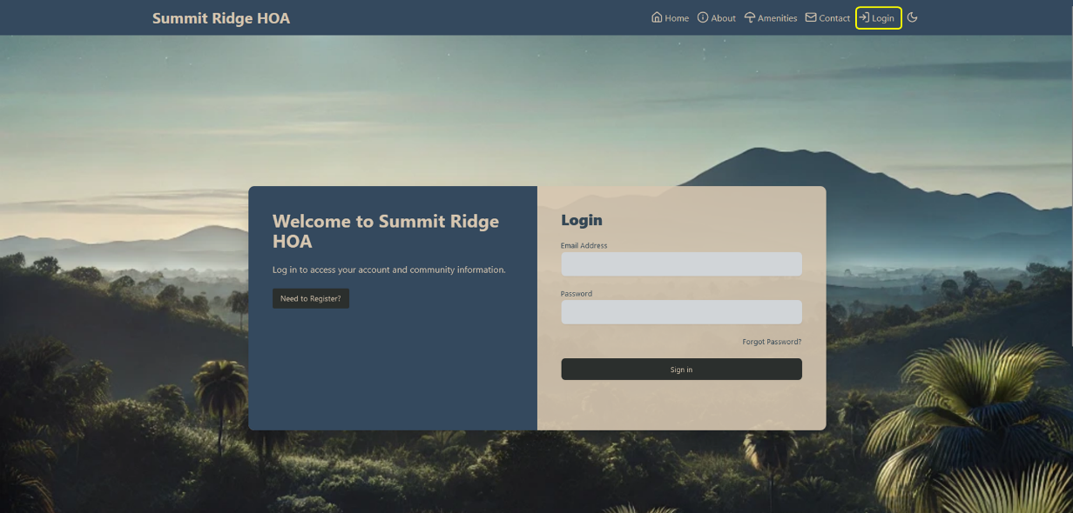

Figure 1: Summit Ridge HOA Login Page - Initial landing page for the HOA Management System.

To begin your account setup:

1. Go to the Summit Ridge HOA website

2. Locate the login section in the upper right

3. Look for the “Need to Register?” option

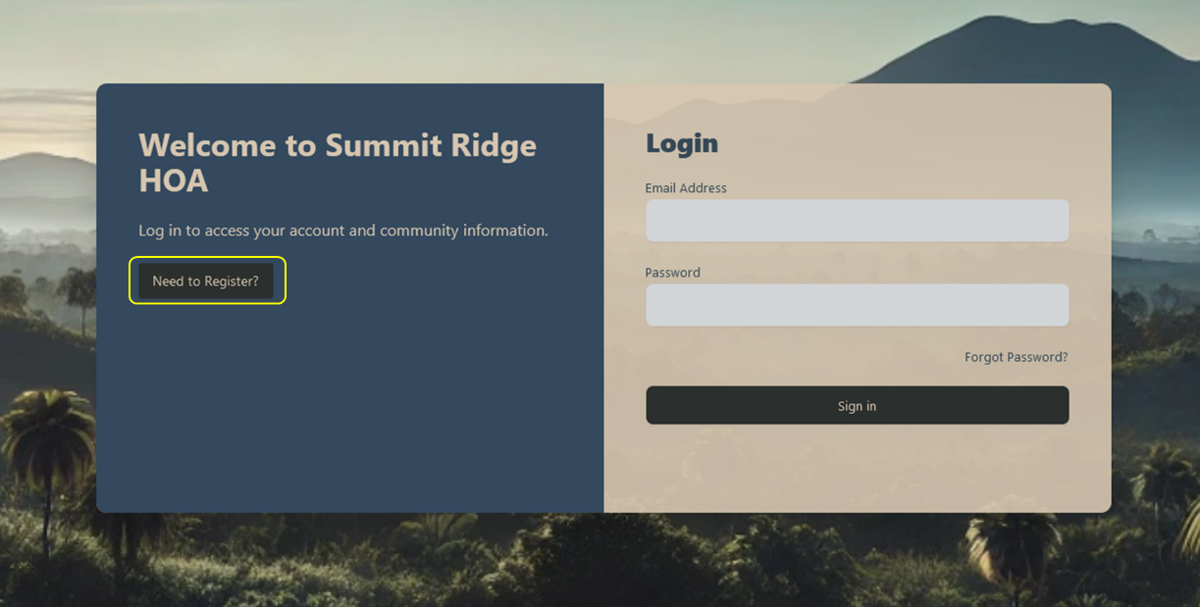

Figure 2: Registration Button - Location of “Need to Register?” button on login page.

After clicking “Need to Register?”:

1. You will need your Account ID, Owner ID, and temporary registration code provided by the HOA

2. Enter these credentials carefully as they validate your identity

3. The system will verify your information before proceeding

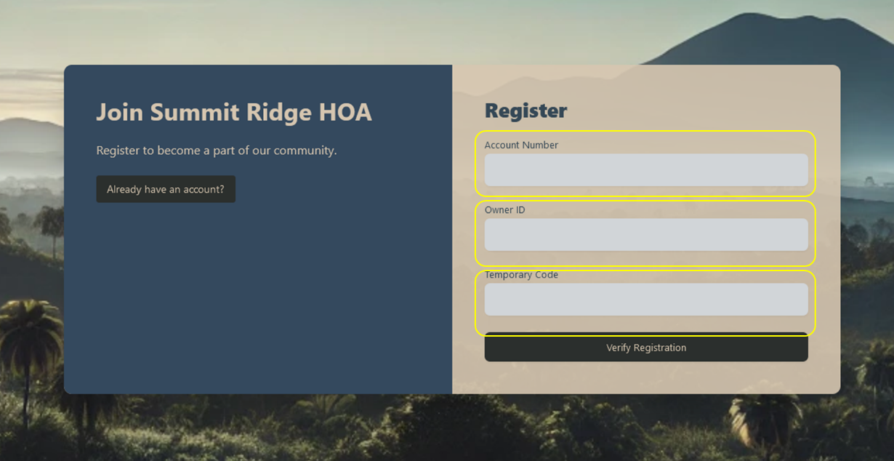

Figure 3: Registration Form - Form for entering Account ID, Owner ID, and temporary registration code.

Once verified:

1. Complete your personal profile

2. Add contact information for important HOA communications

3. Create a secure password that meets system requirements

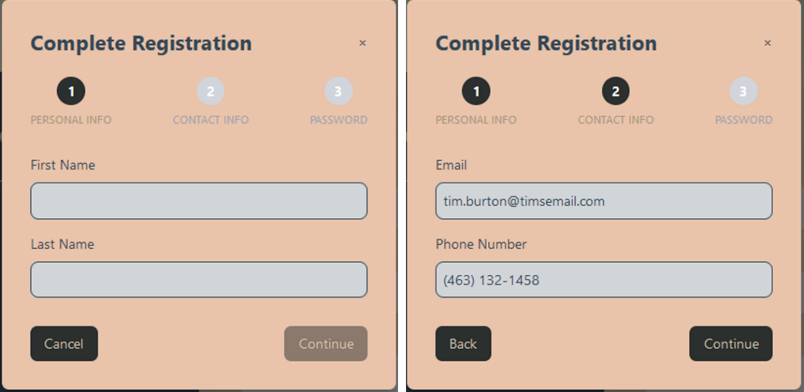

Figure 4: Personal Information Form - Fields for entering name and contact details during registration.

**Security Note:** Your password must be unique and secure. The system requires: - Minimum 8 characters - At least one uppercase letter - At least one number - At least one special character

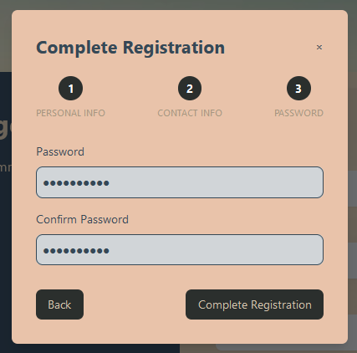

Figure 5: Password Creation - Screen for setting up your permanent password.

Upon successful registration:

1. You will see a confirmation screen

2. Can immediately access your account, by logging in

### Main Interface Navigation

**Purpose:** The interface is designed to provide quick access to all system features while maintaining a clean, intuitive user experience.

**When to Use:** Any time you need to access HOA services, make payments, or view community information.

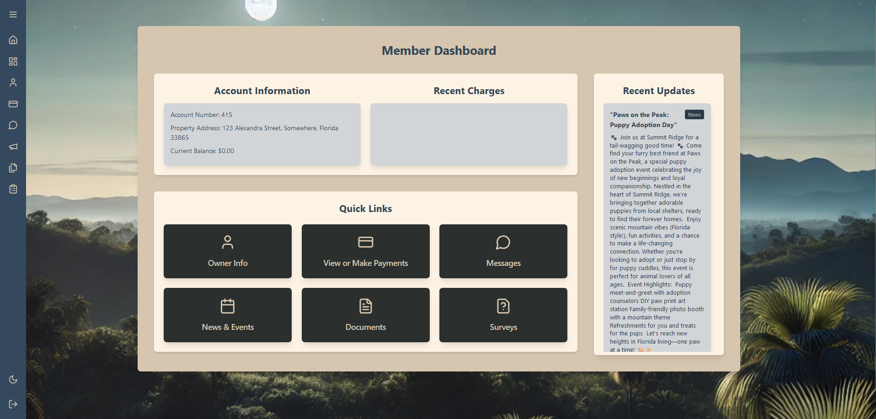

Figure 6: Main Dashboard - Overview of the primary interface elements.

Key Interface Elements:

1. Top Navigation Bar:

* Quick access to public pages
* User account menu
* Notifications
* Theme toggle

1. Sidebar Navigation:

* Main menu for all features
* Collapsible for more screen space
* Always accessible

1. Content Area:

* Displays selected feature
* Responsive to screen size
* Scrollable for long content

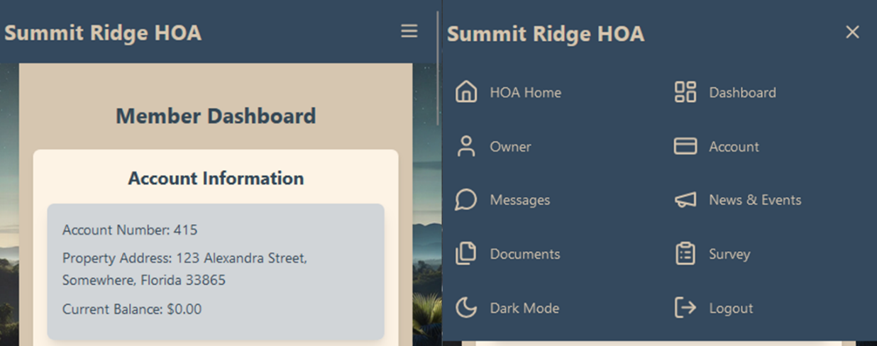

Figure 7: Mobile Navigation - Mobile-friendly menu and layout.

Mobile Considerations:

1. Menu accessed via hamburger icon

2. Full functionality preserved

3. Optimized touch targets

4. Responsive design elements

## Resident Portal Features

### Dashboard

**Purpose:** Your central hub for monitoring account status, viewing recent activity, and accessing key features.

**When to Use:** - Daily/weekly account monitoring - Checking recent transactions - Viewing important announcements - Accessing frequently used features

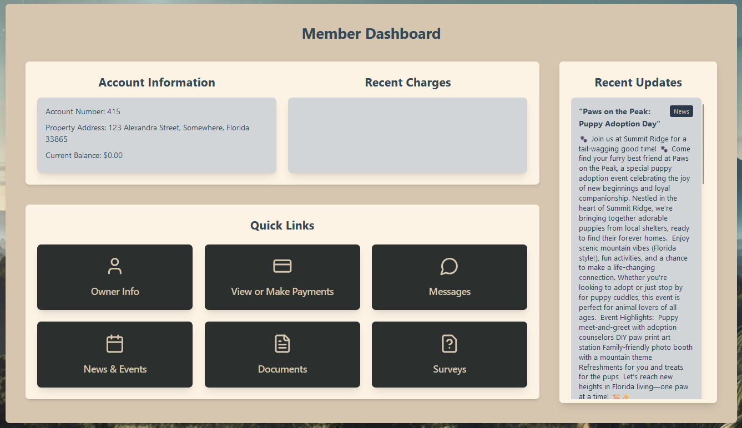

Figure 8: Dashboard Overview - Main dashboard displaying account information and activity.

Dashboard Sections:

1. Account Summary:
   * Current balance
   * Payment due dates
   * Recent transactions
   * Quick action buttons
2. Community Updates:
   * Latest announcements
   * Upcoming events
   * Important deadlines
   * New documents
3. Quick Links:
   * Payment system
   * Document library
   * Message center
   * Community calendar

### Making Payments

**Purpose:** Securely process HOA dues, assessment payments, and other fees associated with your property.

**When to Use:** - Monthly HOA dues payment - Special assessment payments - Violation fee payments - Other community-related charges

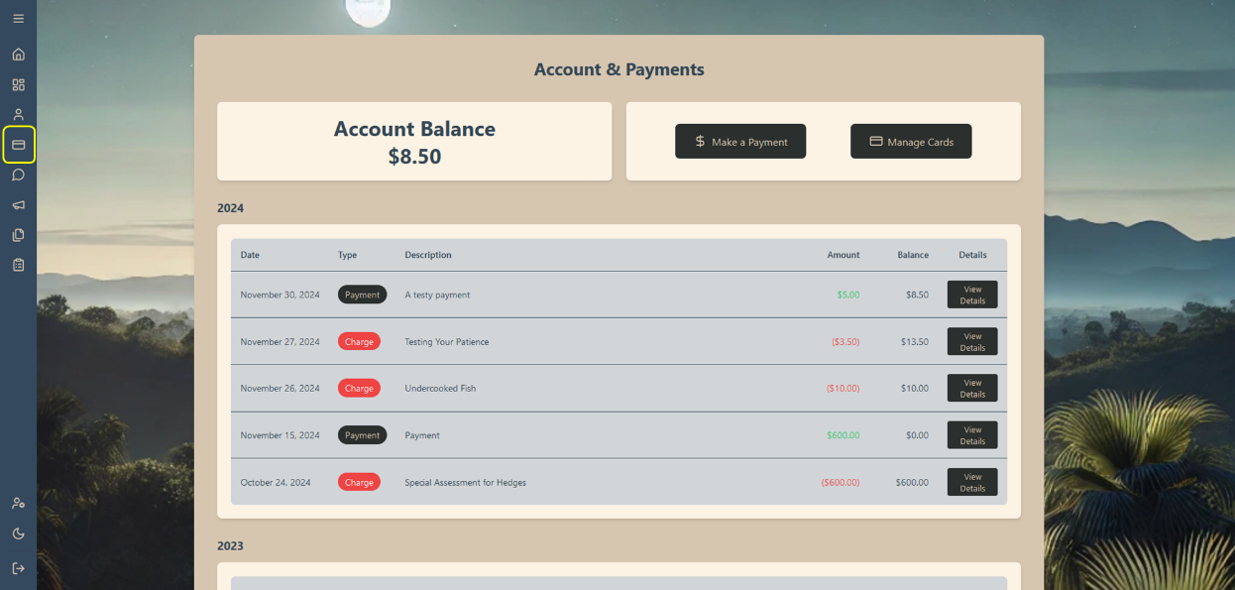

Figure 9: Payments Page - Main payment interface showing balance and options.

Payment Options:

1. One-Time Payment:

* Select payment amount
* Choose payment method
* Review and confirm
* Receive confirmation

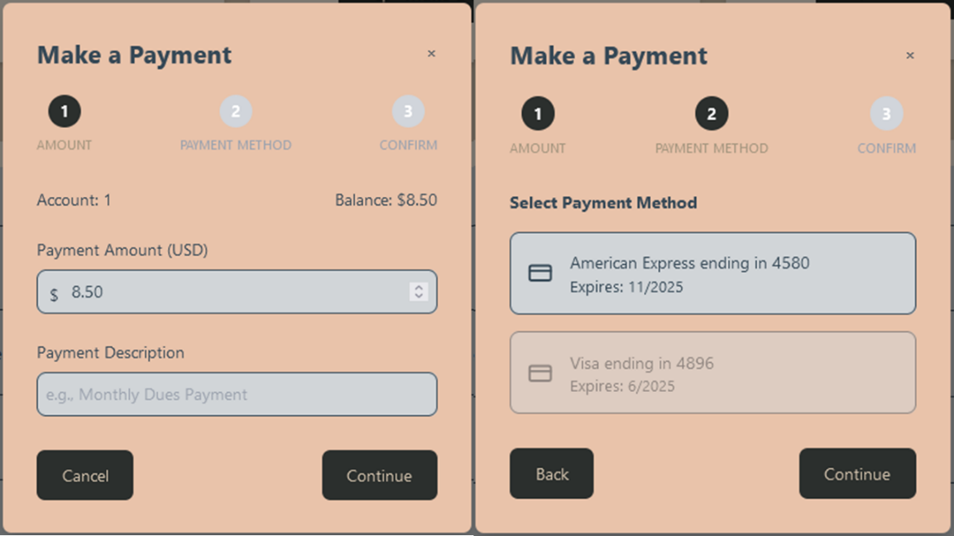

Figure 10: Payment Method Selection - Interface for choosing or adding payment methods and amounts.

Payment Methods:

1. Credit/Debit Cards:

* Add new card (Manage Cards)
* Use saved card (Make a payment)
* Set default payment method (Manage Cards
* Update card information

1. Payment Review:

* Verify amount
* Confirm payment method
* View processing fees
* Submit payment

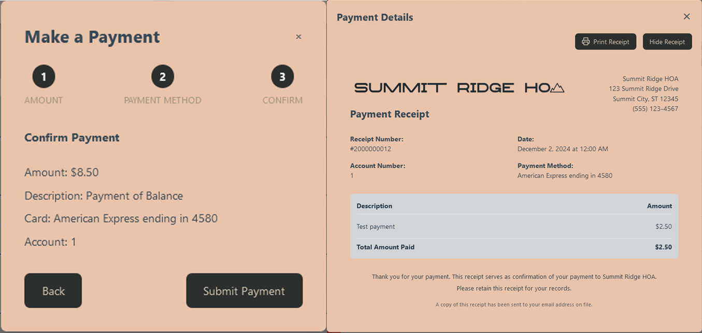

Figure 11: Payment Confirmation - Review screen and receipt generation.

Confirmation Process:

1. Review payment details

2. Submit payment

3. Receive confirmation

4. Download/print receipt

### Document Management

**Purpose:** Access, download, and manage important HOA documents, forms, and community information.

**When to Use:** - Reviewing HOA policies - Accessing community forms - Checking meeting minutes - Viewing financial reports

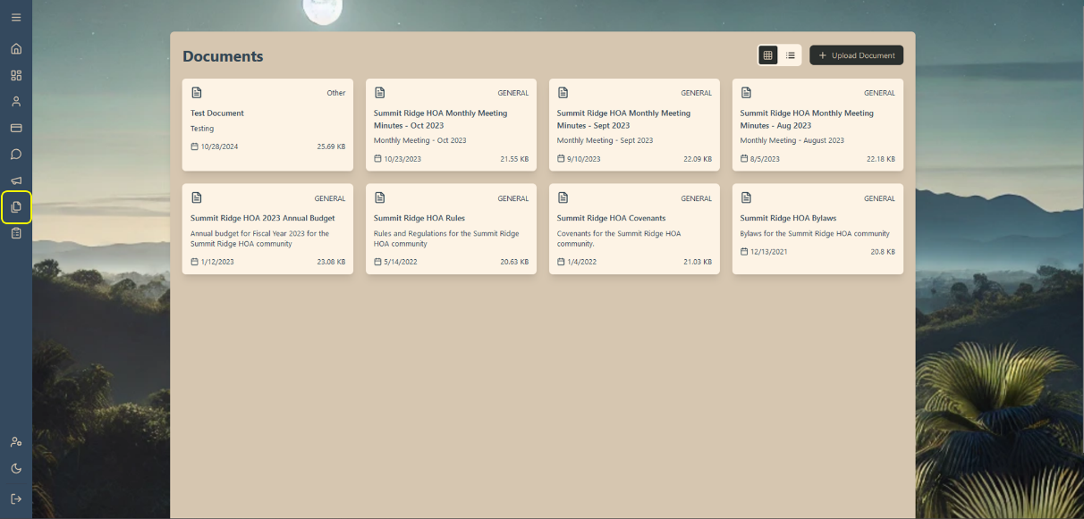

Figure 12: Document Library - Main document management interface.

Document Categories:

1. Governing Documents:

* Bylaws
* CC&Rs
* Rules and regulations
* Policies

1. Community Documents:

* Meeting minutes
* Newsletters
* Event calendars
* Community notices

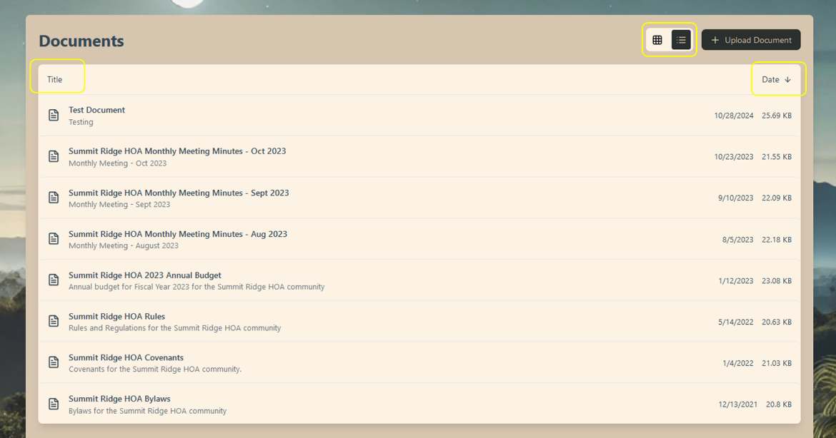

Figure 13: Document View & Filter – Change view of interface for finding documents and filter by Title or Date.

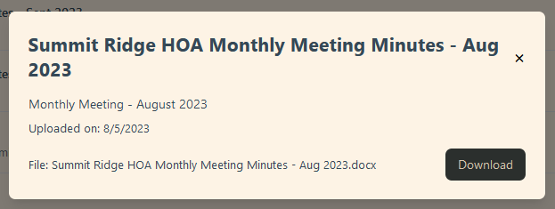

Figure 14: Document Detail View - Expanded view of document information and actions.

Document Actions:

1. View details

2. Download

### Messages

**Purpose:** Communicate with HOA management, board members, and receive important notifications.

**When to Use:** - Submitting inquiries - Responding to notices - Requesting information - Reporting issues

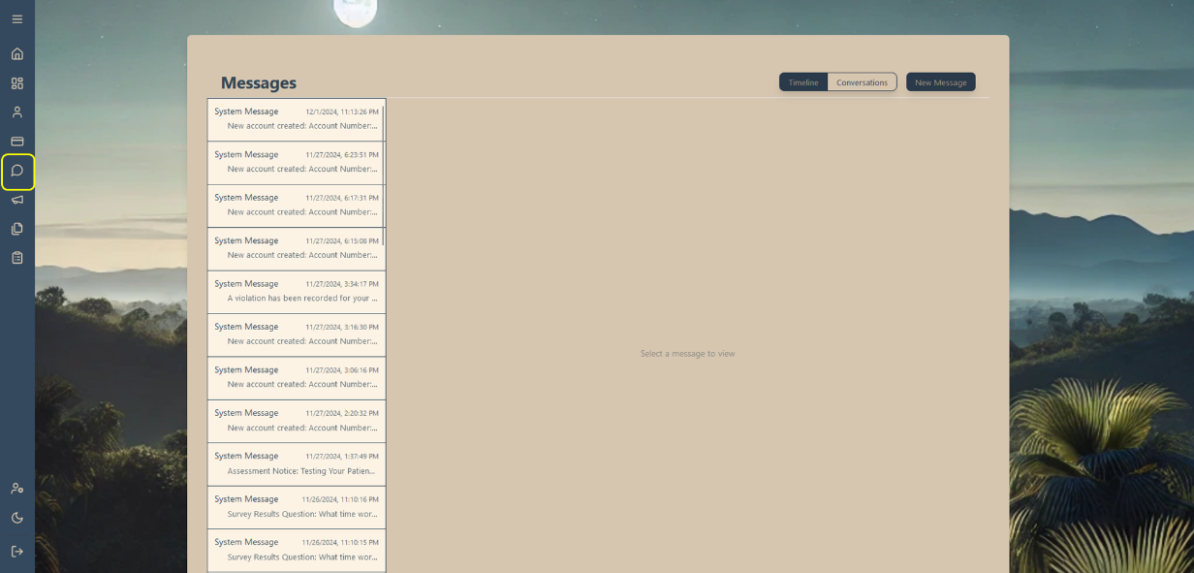

Figure 15: Message Center - Main messaging interface showing inbox and composition options.

Message Features:

1. Compose Message:

* Select recipient
* Write message
* Send message

1. View Messages:

* Read messages
* Reply to messages
* View message history

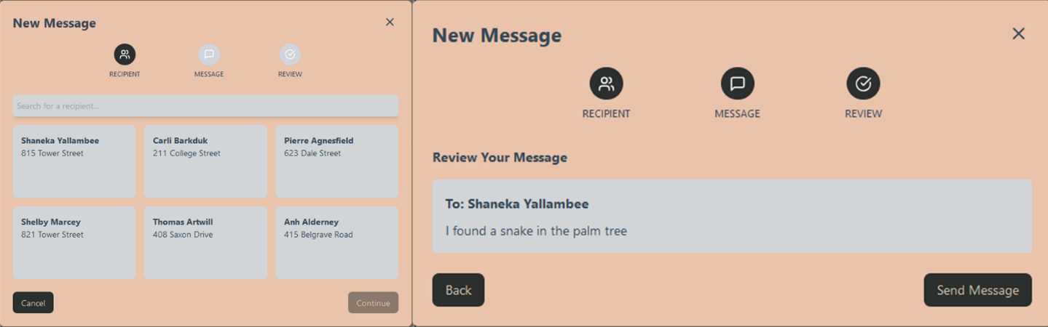

Figure 16: Message Composition - Interface for creating and sending messages.

Message Types:

1. Direct Messages:

* To HOA management
* To board members
* To committees

1. System Messages:

* Payment confirmations
* Important notices
* Account updates

### Announcements & Events

**Purpose:** Stay informed about community news, upcoming events, and important notices. This feature ensures you never miss critical information or community gatherings.

**When to Use:** - Check community updates - View upcoming events - RSVP to gatherings - Review past announcements

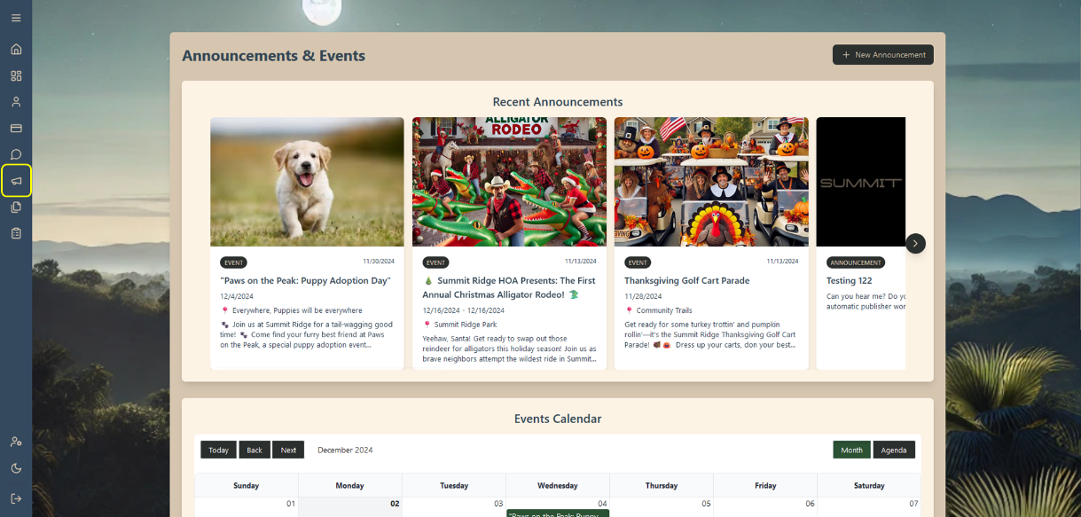

Figure 17: Announcements Page - Main announcements and events interface.

Announcement Features:

1. News Feed:

* Latest announcements
* Community updates
* Important notices
* Policy changes

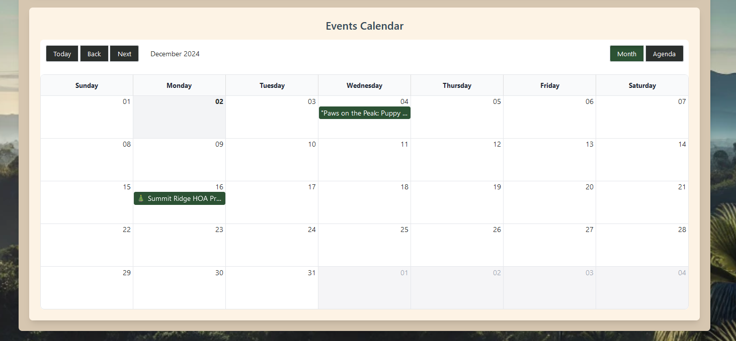

Figure 18: Event Calendar - Calendar view showing upcoming community events.

Event Management:

1. View Events:

* Upcoming events list
* Calendar view
* Event details
* Location information

1. Event Actions:

* RSVP to events
* Add to personal calendar
* Get event reminders
* View event history

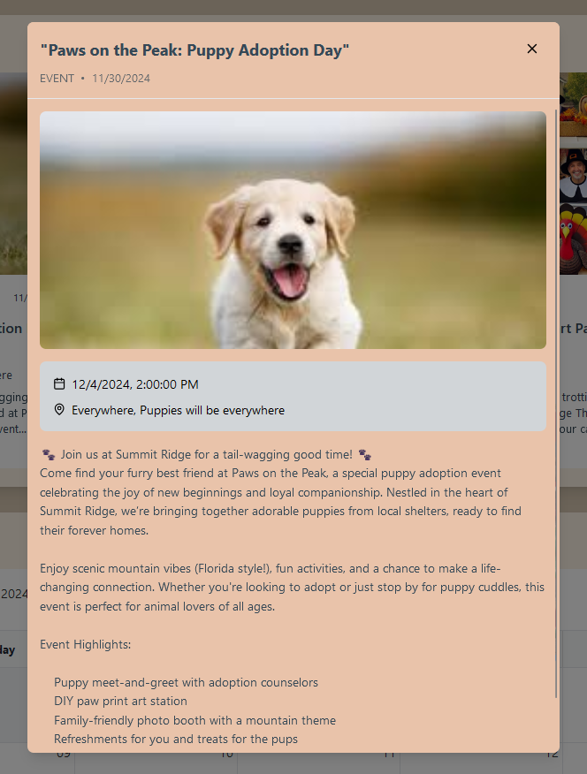

Figure 19: Event Details - Expanded view of event information and RSVP options.

Event Details Include:

1. Date and time

2. Location

3. Description

4. Required actions

5. Contact information

### Surveys

**Purpose:** Participate in community decision-making and provide feedback on important matters affecting the HOA.

**When to Use:** - Vote on community issues - Provide feedback - Participate in planning - Share preferences

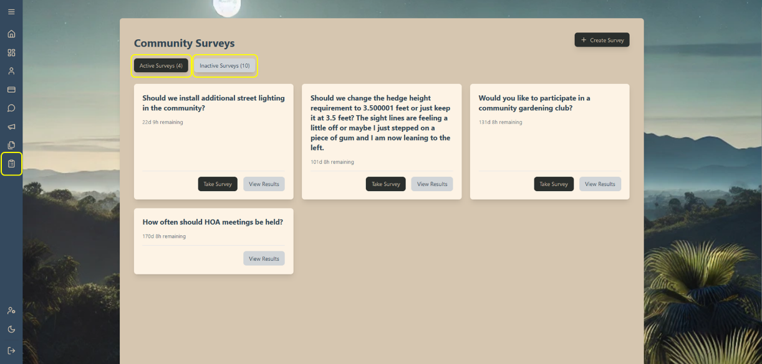

Figure 20: Active/Inactive Surveys - List of current surveys requiring resident input or past surveys with results.

Survey Types:

1. Community Polls:

* Quick feedback
* Simple choices
* Immediate results

1. Formal Surveys:

* Detailed questions
* Multiple choice
* Extended responses
* Voting matters

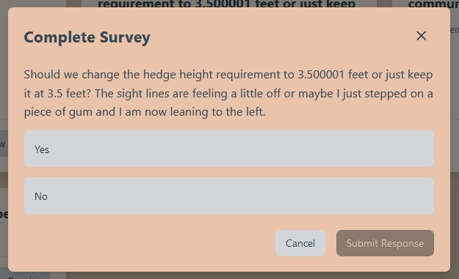

Figure 21: Survey Response - Interface for completing a survey.

Taking a Survey:

1. Review question/topic

2. Consider options

3. Submit response

4. View results

### Profile Management

**Purpose:** Maintain your personal information and communication preferences to ensure effective interaction with the HOA.

**When to Use:** - Update contact information - Modify communication preferences - Change password - Review account settings

[Insert Screenshot] Figure 22: Profile Settings - Main profile management interface.

Profile Sections:

1. Personal Information:

* Name
* Contact details

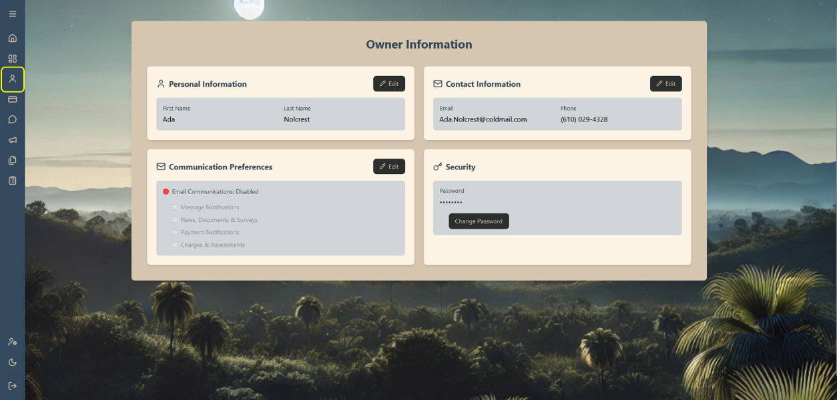

Figure 23: Communication Preferences - Settings for notifications and communications.

Notification Settings:

1. Email Preferences:

* Community updates
* Payments
* Violations / Assessments

Security:

1. Change password:

* Click change password
* Enter new password and confirm the new password

## Board Member Features

### Board Dashboard

**Purpose:** Access specialized tools and features for HOA management and administration (Board Members Only).

**When to Use:** - Manage community affairs - Handle violations - Process requests - Oversee financials

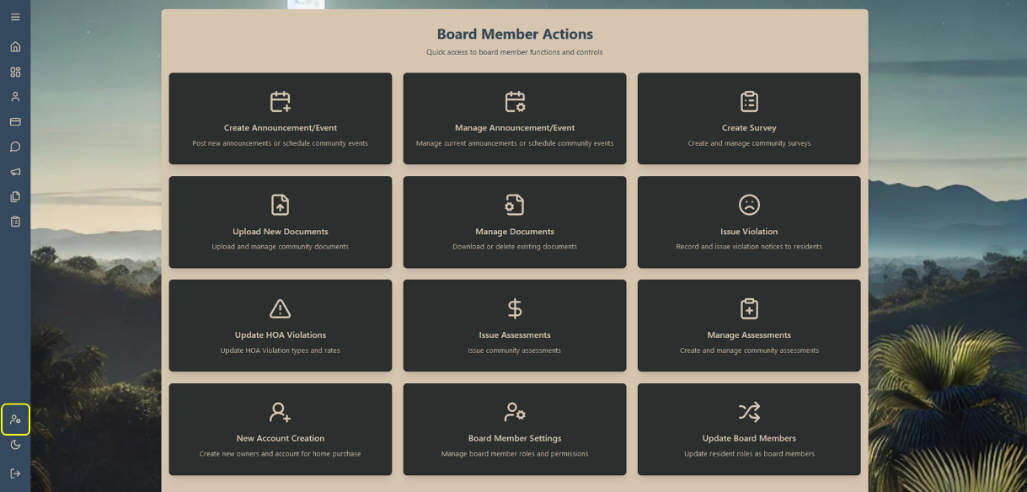

Figure 24: Board Member Dashboard - Specialized interface for board member actions.

Available Actions:

1. Community Management:

* Issue and manage violations
* Issue and manage assessments
* Manage documents
* Manage announcements and events
* Create surveys

1. Administrative Tasks

* Create new accounts
* Update board member roles and permissions
* Update the board members

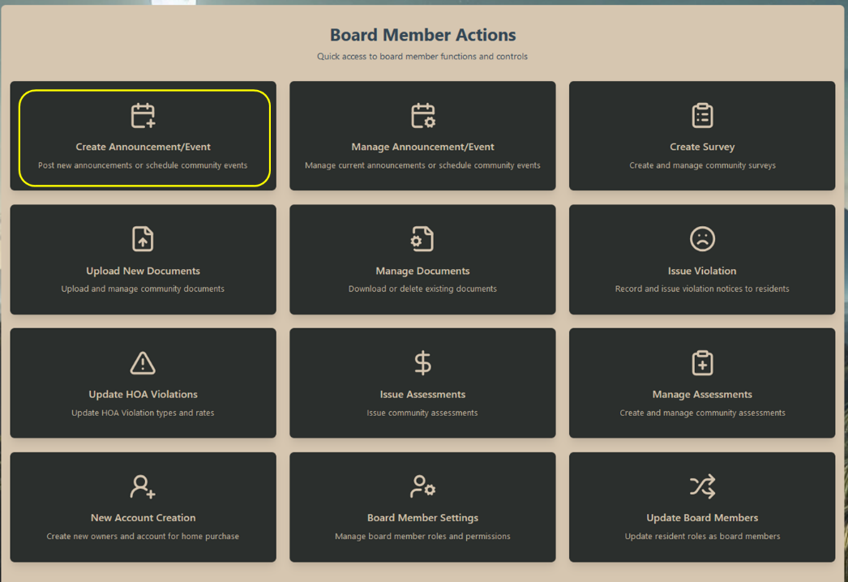

Figure 25: Board Action Cards - Quick access to common board member tasks. There are 12 total actions that a board member can take. Each has their own link and modal. Board member permissions are applied, and the dashboard is visibly and functionally disabled if additional permissions are required.

### Violation Management

**Purpose:** Document, issue, and track violations of community guidelines and HOA rules.

**When to Use:** - Record rule violations - Issue notices - Track compliance - Process appeals

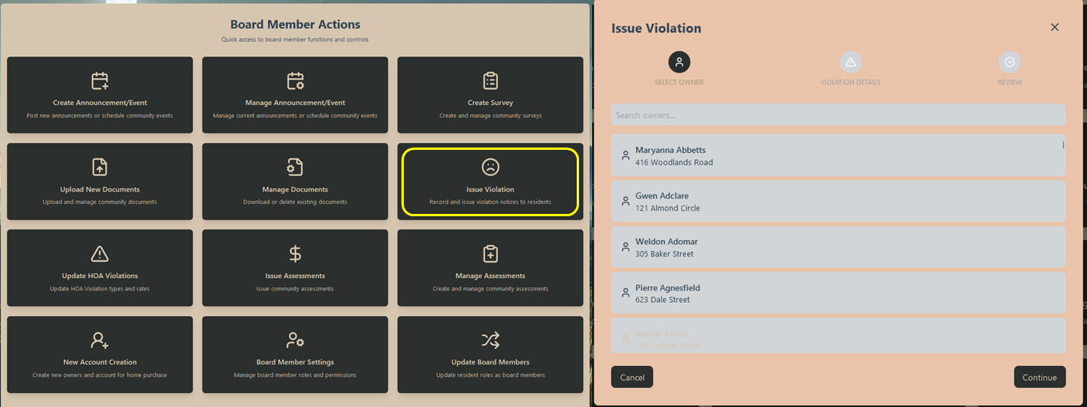

Figure 26: Violation Processing - Interface for managing community violations.

Violation Process:

1. Document Violation:

* Select Owner
* Select violation type
* Select the violation date
* Review the violation before submission
* Submit

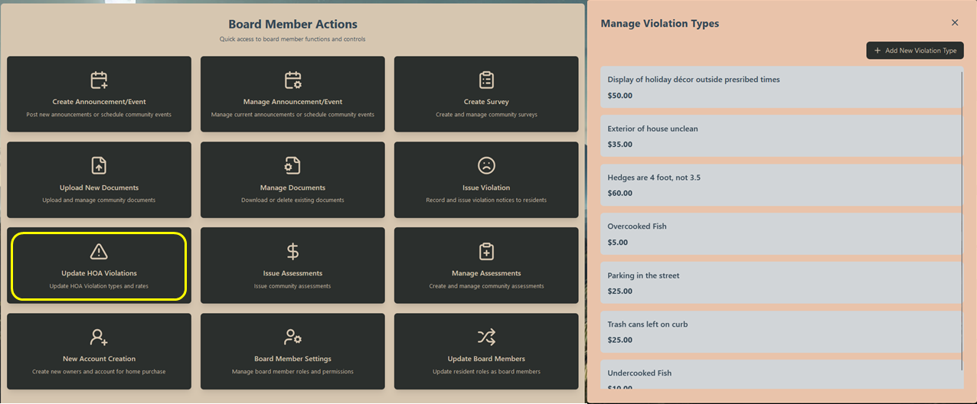

Figure 27: Violation Types - Management interface for violation categories and fines.

Managing Violations:

1. Create violation types

2. Set fine amounts

### Assessment Management

**Purpose:** Create and manage community assessments for various purposes.

**When to Use:** - Issue regular assessments - Create special assessments - Manage payment schedules - Track collection status

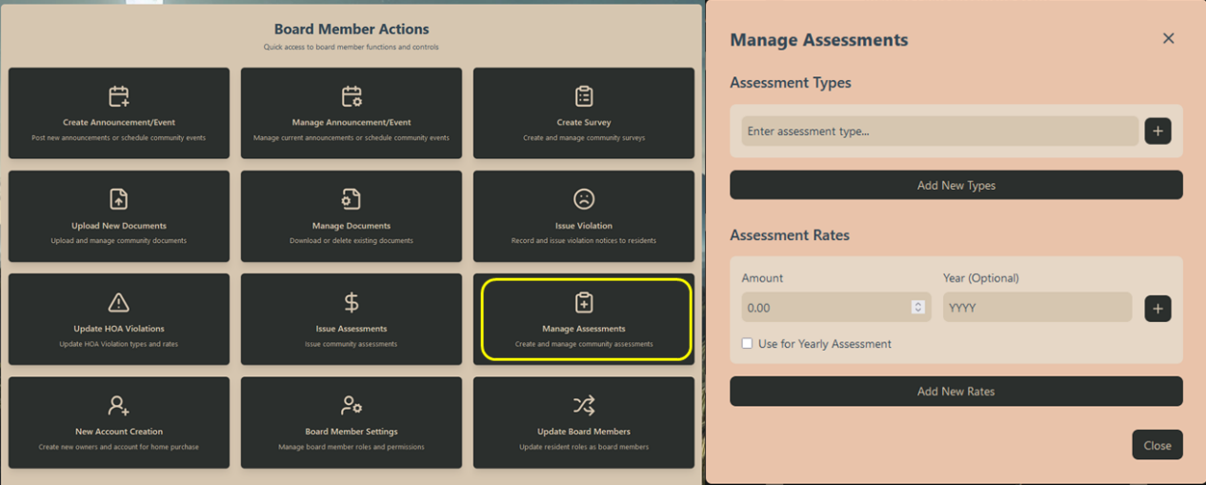

Figure 28: Assessment Creation - Interface for creating new assessments.

Assessment Types:

1. Regular Assessments:

* Annual dues
* Monthly fees

1. Special Assessments:

* Project funding
* Emergency repairs
* Capital improvements

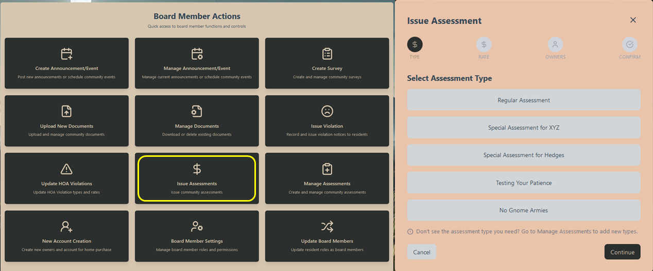

Figure 29: Issue Assessment - Interface for managing assessment issuance.

Distribution Options:

1. All properties

2. Individual properties

3. Groups of properties

### Document Administration

**Purpose:** Manage, organize, and distribute important HOA documents and maintain the community’s document repository.

**When to Use:** - Upload new documents - Update existing files - Organize document categories - Set access permissions

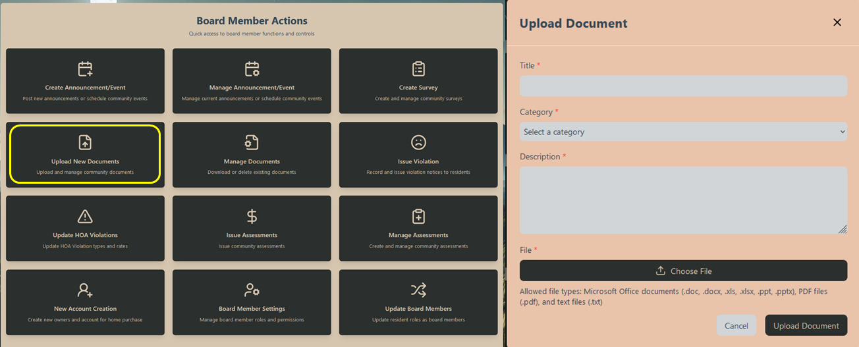

Figure 30: Document Upload - Interface for adding new documents to the system.

Document Upload Process:

1. Select Document Type:

* Official records
* Meeting minutes
* Financial reports
* Community notices

1. Add Metadata:

* Title
* Description

1. Add File

* Allowed file types: Microsoft Office documents (.doc, .docx, .xls, .xlsx, .ppt, .pptx), PDF files (.pdf), and text files (.txt)

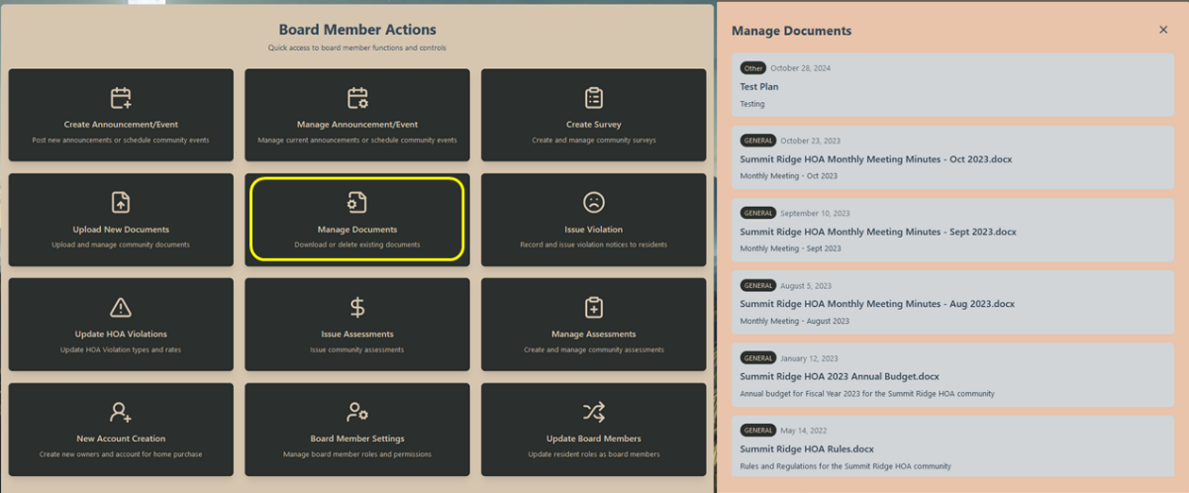

Figure 31: Document Management - Interface for editing, maintaining or removal of documents.

### Survey Creation

**Purpose:** Design and distribute surveys to gather community feedback and conduct official votes.

**When to Use:** - Community polling - Official voting - Feedback collection - Planning input

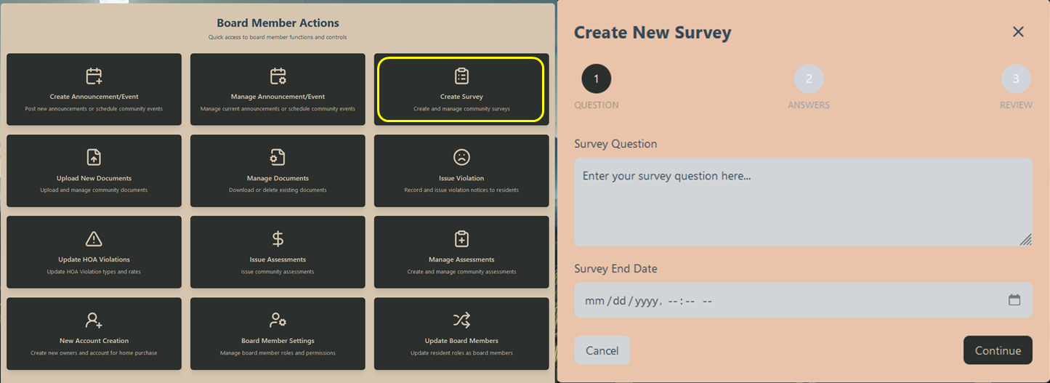

Figure 32: Survey Creation - Interface for building new surveys.

Survey Creation Process:

1. Survey Settings:
   * Survey Question (text-based question)
   * Survey end date
   * Survey Answers (min: 2, max: 4)

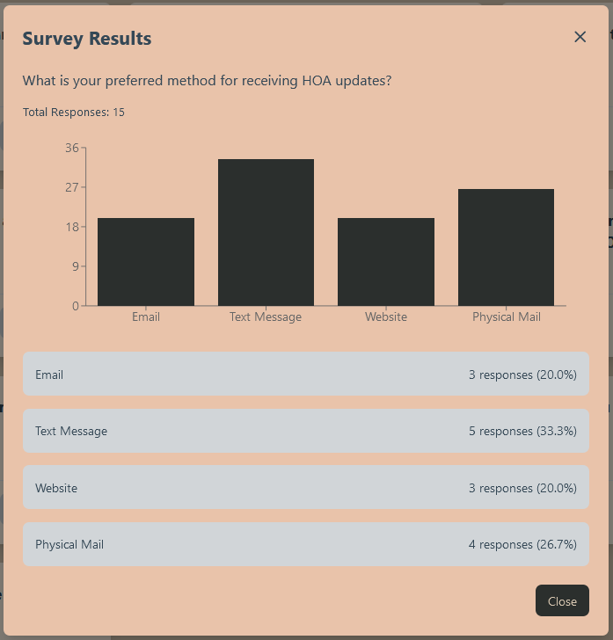

Figure 33: Results Analysis - Interface for viewing and analyzing survey responses. Available from the survey page. Text based survey results sent as system messages.

Results Features: 1. Response Analytics: - Participation rates - Response breakdown - Demographic data - Trend analysis

### Account Management

**Purpose:** Create and manage resident accounts, handling new move-ins and departures.

**When to Use:** - New resident setup - Account transfers - Status changes - Access control

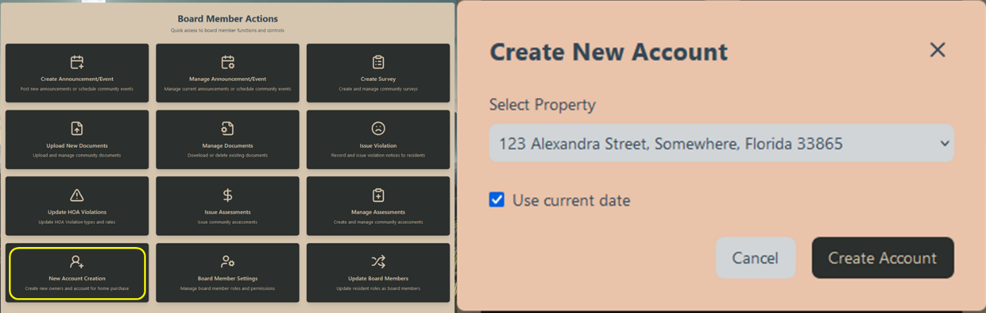

Figure 34: New Account Creation - Interface for setting up resident accounts.

Account Setup Process:

1. Property Assignment

* Select property address
* Set effective date
* Note credentials or get from system message
* Give credentials to closing agent / law firm handling closing

# Contact

For help related to any functionality with this HOA Management System please contact your system administrator or the help team at [TheSummitRidgeHOA@proton.me](mailto:TheSummitRidgeHOA@proton.me).